**Дата**: 22.04.2025

**Клас**: 9-АБ

**Предмет**: англійська мова

**Тема:** Яке місце ти б хотів відвідати?

**Мета:** : формувати навички вживання лексичних одиниць по темі; удосконалювати навички читання, аудіювання й усного монологічного мовлення; розвивати пізнавальні інтереси учнів; виховувати інтерес до самостійного пошуку потрібної інформації, а також загальну культуру учнів.

**Вчитель**: Руда Д.В.

Хід уроку

1.Greeting

Good afternoon, guys! I’m glad to see you. Are you ready to start our lesson? All set?

2. Wаrm up / Listening

Уважно слухати аудіо трек і дати відповідь на питання <https://www.youtube.com/watch?v=uXwZ9FTCNeM> .

3. Speaking

Дати усно відповіді на питання :

Where did you spend your last vacation? Your summer vacation? Your Christmas vacation?

Where will you go on your next vacation?

Would you like to take a cruise? Where to? With who?

Do you prefer traveling on a hovercraft or a ferry?

Would you prefer to stay at a hotel/motel or camp while on vacation?

Would you rather visit another country or travel within your own country?

Would you rather go to a place where there are a lot of people or to a place where there are few people?

Do you find more fulfillment from your leisure activities including vacations than from your job?

Do you think the type of vacation one takes reflects one's social status?

What are popular tourist destinations in your country?

Have you been to any of them?

Which would you recommend if you could only recommend one? Why?

Do you prefer active or relaxing holidays? Why?

Which is better, package tour or a tour you organize and book yourself?

Why do you travel?

Why do people travel?

Would you like to go back to the same place?

Did you find anything of particular interest? / Did you get attracted to anything special?

What are some benefits of travel?

Why do people travel?

What is your favorite mode of travel?

Have you travelled in business class?

When you were a child did your family take a vacation every year?

Do you prefer a budget or first class hotel? Why?

Do you travel with a lot of baggage or do you like to travel light?

What is your favorite method of travel at your destination? Train? Bus? Boat? Bicycle? Backpacking?

What is the best kind of holiday for different ages of people? Children? Teenagers? Adults? Elderly people?

Do you think it is a good idea to travel with friends, or alone? How about with your family?

If you had $100,000, where would you go on holiday? How about if you had $10,000? What about $1,000?

Which countries have you travelled to?

4. Повторення

Словник:

*Sightseeing tour-екскурсія визначними місцями*

*Signature- підпис*

*To border-межувати*

*To be surrounded by-бути оточеним*

*To be situated in-розташований*

*To be washed by-омиваєтсья*

*To consist of-складатися з …*

*To insist-наполягати*

*In order to –для того, щоб ..*

*In smb`s footsteps- по чиїхось слідах*

*Incomplete- неповний, незакінчений*

*Related- споріднений, пов’язаний*

*Disciplined-дисциплінований*

*Dominate-домінувати*

*To forbid-забороняти*

*Hospitable-гостинний*

*To make smb aware of smth- давати комусь знати про щось*

*To be a waste of time- марно витрачати час*

*To be available-бути доступним,наявним*

*To be brought up-бути вихованим, виховуватись*

*To be engaged in – бути зайнятим чимось*

5. Writing

Transport - <https://www.liveworksheets.com/w/en/english-second-language-esl/2118916>

<https://www.liveworksheets.com/w/uk/english-second-language-esl/7652497>

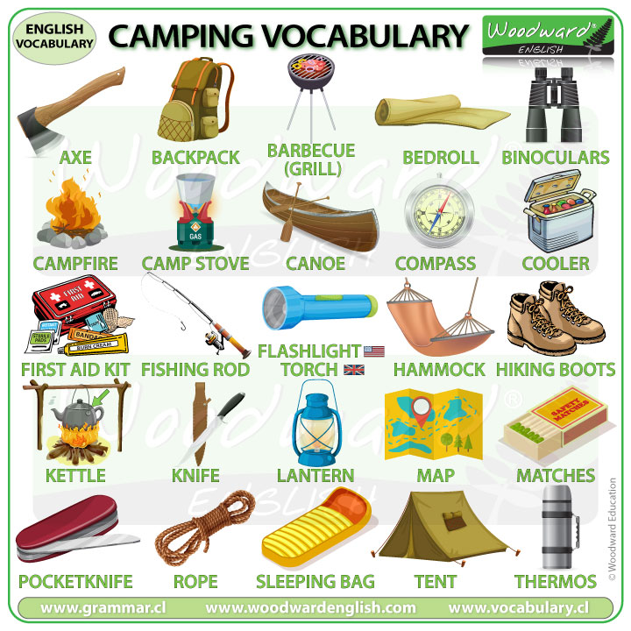

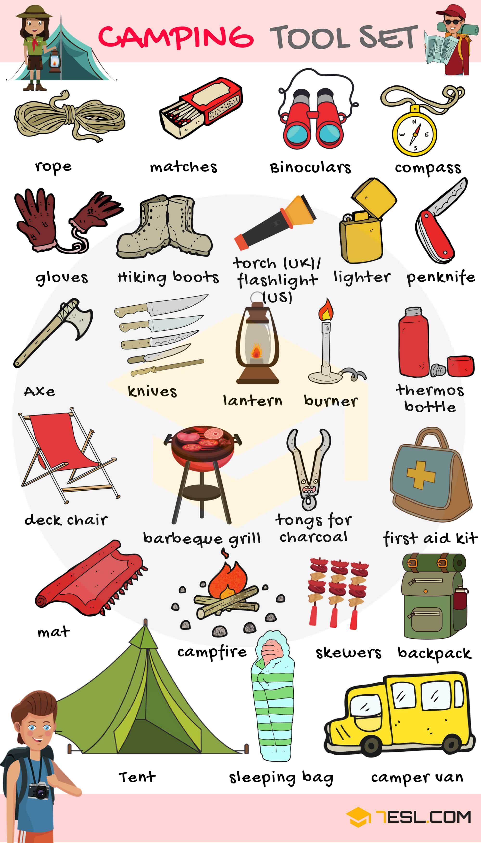

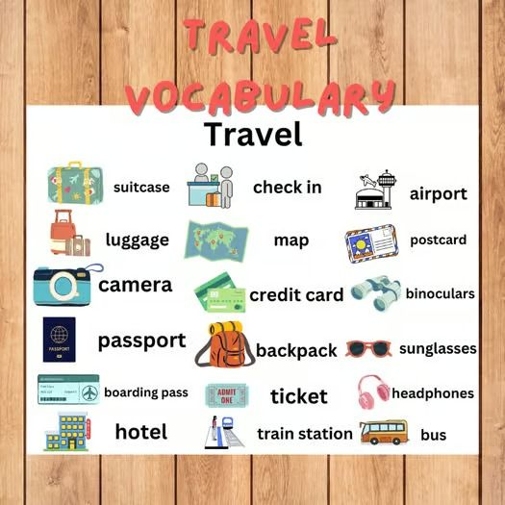

6. Vocabulary

*A narrator- оповідач*

*Natural habitat-природне середовище*

*Observation – спостереження*

*Offensive-образливий*

*To originate from- походити від*

*TALKATIVE - балакучий*

*True-to-life- Життєво правдивий*

*To vote-голосувати*

7. Homework

1. Написати міні-есе «Why is travel good for us?» .

2. Повторити слова в словнику.